**Create App Service and Deploy Files using FTP – Azure CLI**

This sample script creates an app in App Service with its related resources, and then deploys a static HTML page using FTP. For FTP upload, the script uses [cURL](https://en.wikipedia.org/wiki/CURL) as an example. You can use whatever FTP tool to upload your files.

**Step 1:** Open Microsoft Azure Portal

<https://portal.azure.com>

**Step 2:** Click on **Cloud Shell** icon



**Step 3:** Select Bash from Drop down option



**Step 4:** Specify Source Web Page URL

warurl=https://raw.githubusercontent.com/Azure-Samples/html-docs-hello-world/master/index.html

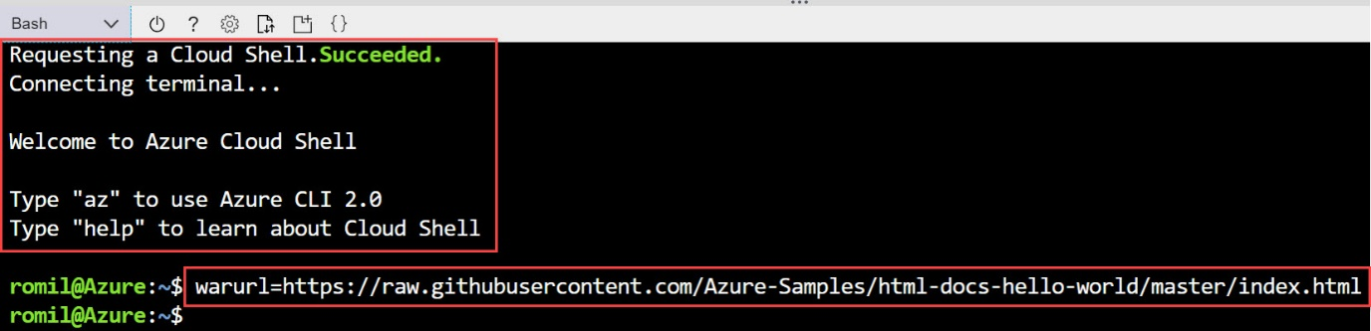

**Step 5:** Declare Web App Name

webappname=mywebapp$RANDOM



**Step 6:** Download Sample HTML Page (index.html)

curl $warurl --output index.html

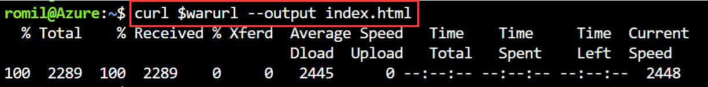

**Step 7:** Create Resource Group on any location ex. westeurope

az group create --location westeurope --name myResourceGroup

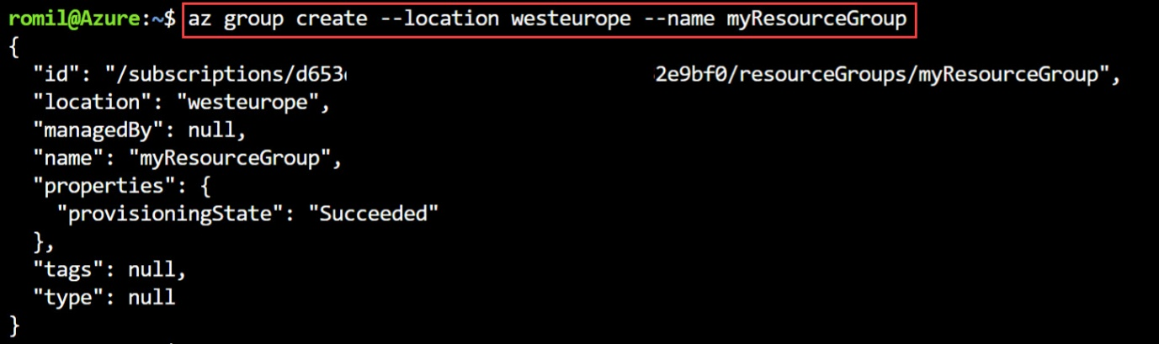

**Step 8:** Create App Service Plan with Free Pricing Tier

az appservice plan create --name myAppServicePlan --resource-group myResourceGroup --sku FREE

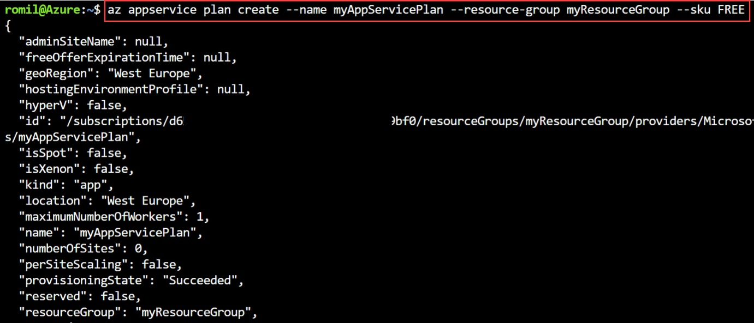

**Step 9:** Create Web App

az webapp create --name $webappname --resource-group myResourceGroup --plan myAppServicePlan

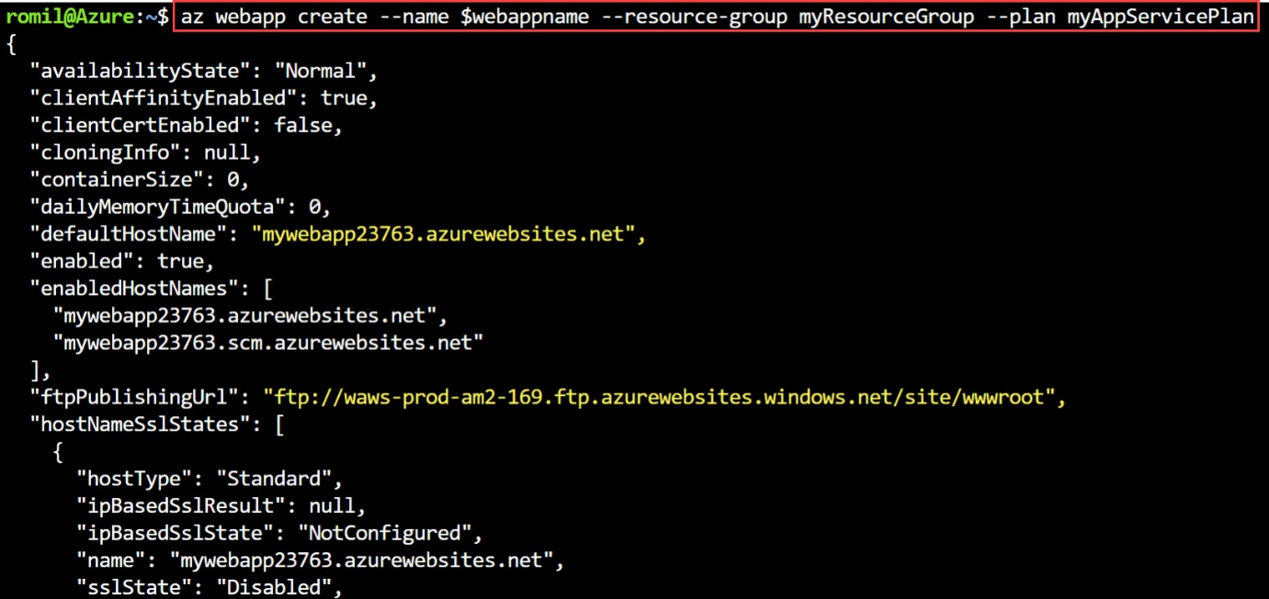

**Step 10:** Get FTP Publishing profile and query for publish URL and credentials

creds=($(az webapp deployment list-publishing-profiles --name $webappname --resource-group myResourceGroup \

--query "[?contains(publishMethod, 'FTP')].[publishUrl,userName,userPWD]" --output tsv))



**Step 11:** curl to perform FTP upload.

curl -T index.html -u ${creds[1]}:${creds[2]} ${creds[0]}/

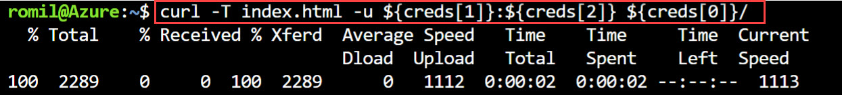

**Step 12:** Run below command to see result inn browser

echo http://$webappname.azurewebsites.net

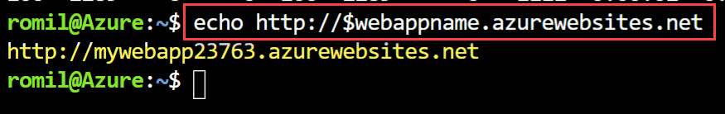

**Step 13:** To Delete Resource Group

az group delete --name myResourceGroup

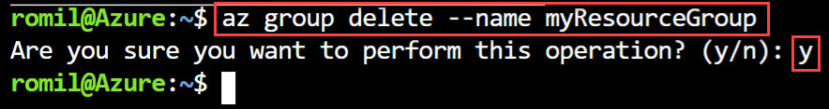

Step 13:

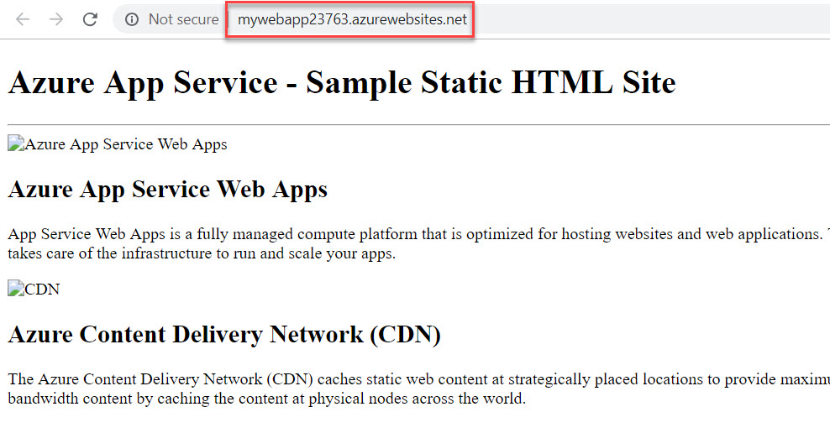

Step 14:

